Workshop and Guidance Day Program 2026
All sessions run 10- 3 at Sth Barwon Community Centre 33 Mt Pleasant Rd Belmont

 | Date | Tutor | Project/technique | Description
1. | Saturday and Sunday January 17 & 18  Cost $120. Kit $200  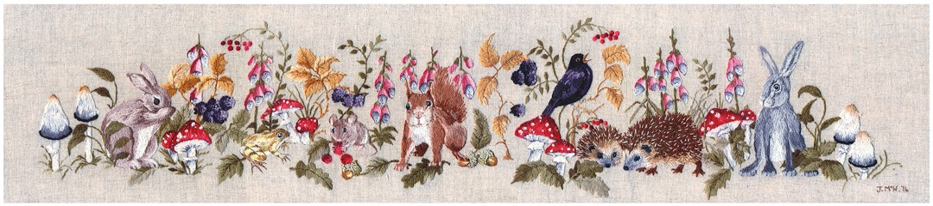 | Jenny McWhinney  Code JMW 1 | Woodlands – Surface Stitchery | The design measures 1 mitre x 25 cm. The kit includes the design printed on linen overlocked and stabilised, and threads  The lessons include learning about understanding aspects of drawing which makes stitching and recreating and achieving realistic animals much easier.  Kit cost $200 to be paid to Jenny on the day
2. | Sunday January 18  Cost $ 10 to be paid through Member Jungle  Plus meal as arranged  Meal 5.30  Zoom 7-8pm | Phillipa Turnball | Basic Rules of Crewel work Embroidery | Phillipa has been producing crewel embroidery kits for over 25 years- enabling her passion for historical embroidery and for keeping the designs and techniques from the past alive and thriving
3. | WEDNESDAY Feb 11  10- 3. $25  Kit $10  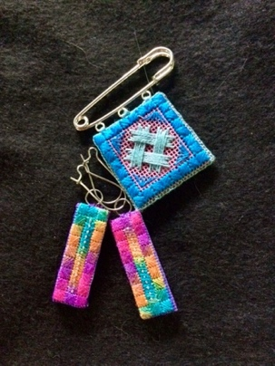 | Pauline Veale  Code PV1 | Stitched Jewellery | Pauline designed and stitched these delicate contemporary pieces for the gift stall in 2023. If you would like to make some for yourself or to make as gifts for friends this is a good opportunity. Worked on congress cloth
4. | FRIDAY 20th February  10-3. $25  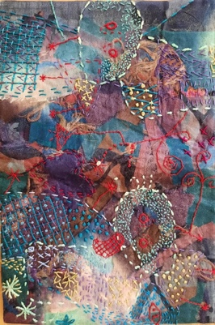 | Gillian Norris  Code GN1 | Book Cover from a Scarf. | Learn the foundational skills of fibre art by working on a beautiful scarf—your raw material! Basic stitches for beginners will be taught and used to follow guided patterns. For more experienced stitchers, this is a chance to use those essential stitches in unexpected and creative ways to build texture. Once the fabric is complete, you will learn how to transform it into a unique, custom-fit book cover.
5. | Saturday and Sundays  Feb 28/March1  March 28 & 29  April25 & 26  Assessment Sat May 23  Intermediate Certificate will run 10- 2 | Susan Davis  Code SD 1 | INTERMEDIATE CERTIFICATE IN BLACKWORK | See separate handout
6. | Friday March 6th  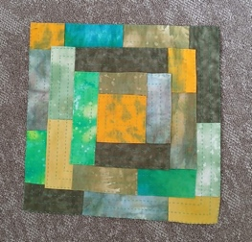 | Marion Dines  Code MD1 | Kawandi 2 | The Kawandi class in 2025 generated so much interest Marion has agreed to another session and has added her learning that “going bigger is easier than small”. This sample lends itself to using one of those jelly rolls you have stashed. But is also suitable for use of your fabric collections
7 | Wednesday April 8th $25 | Jo-Anne Britt  Code JO1 | Bojagi | Bojagi is a traditional wrapping cloth from Korea. They were made to wrap around gifts using scrap fabrics (poorer families) to beautifully coloured silks (wealthier families).Traditional Jogakbo sewing entailed hand triple stitched seams called gekki.  In contemporary bojagi, seams can be hand or machine stitched and there are three types of seams as well as additional hand stitched features.
8 | Friday May 15th  $25  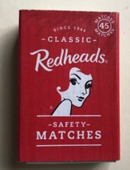 | Gail Joorden  Code GJ1 | Create a garden in a matchbox | This class is a little bit of fun, inspired by Alison Cole, Gail will challenge to design and work a garden in miniature
9 | Saturday & Sunday June 20 & 21  Price TBC  Kit $35 includes colour notes for all 3 samplers and either 18 count or 24 count fabric for 1)  Optional threadpacks18 count $42 7 skeins of thread for 1 sampler  24 count $36 ( includes 6 skeins of thread for 1 sampler)  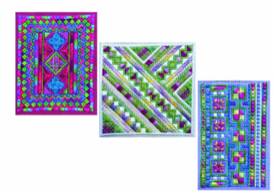 | Anee Maree Mayes Anderson  Code AMMA1 | A Trio of Samplers | This workshop includes 3 simple designs showcasing the variety of ways that canvas work embroidery can be used to create beautiful textures and pattern. Students will receive all three designs in the pattern notes and can choose whether to work just one or purchase materials for all three. During class there will be discussion of the ways elements can be mixed and matched across designs to enable even more possibilities
10. | Friday July 10  $65  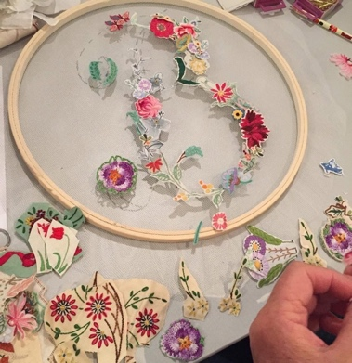 | Louise Saxton  Code LS1 | MEMENTO MONOGRAM | In this class participants will make a reclaimed needlework memento, using the initial of someone’s first name. It may be their own initial or that of someone they wish to remember. Embroidery and lace are imbued with intimacy and profound personal meaning for both the maker and the receiver and by reclaiming discarded and disinherited needlework, your ‘memento monogram’ will also hold personal meaning for you and for the person it honours.
11. | Wednesday July 22nd  $25  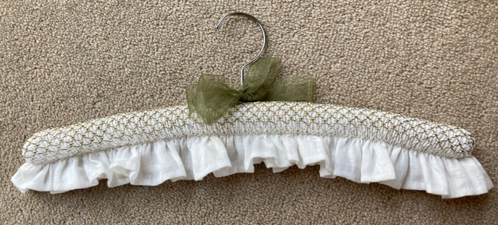 | Dianne Hodder | A taste of Smocking | You will learn basic stitches of smocking.  How to read smocking graphs.  Stitch a panel and learn how to construct and complete a coat hanger.
12 | Monday August 17  $25  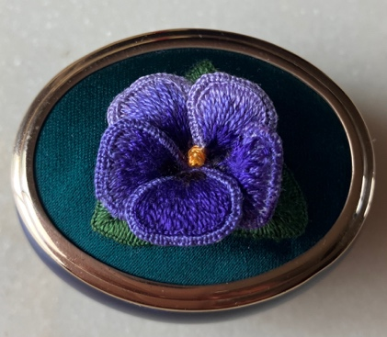 | Marjorie Kavanagh  Code MK1 | Beginner Stump Work – A Pansy | This class gives you a taste of basic stump work techniques to produce a delightful pansy.
13 | Wednesday August 12  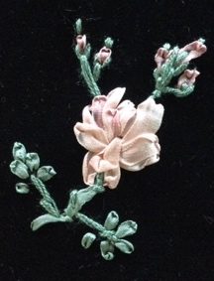 | Jenny Bakos  Code JB1 | The Basics of Ribbon Embroidery | In response to requests the session will introduce participants to the basic techniques involved in ribbon embroidery. You will have the chance to combine the techniques to create images
14 | Friday August 28  Friday September 4th | Christine Burton!!! | Project to be Confirmed
15 | Wednesday December 16th  Free Catering cost |  | Christmas Surprise Class | Our traditional Christmas party!

